PROPAGATION OF ARTEMISIA ARBORESCENS L. BY STEM-CUTTING: ADVENTITIOUS ROOT FORMATION UNDER DIFFERENT CONDITIONS

Marcello Militello¹, Giancarlo Fascella^{2*}, Alessandra Carrubba¹
¹D/SAGA (Dipartimento dei Sistemi Agro-Ambientali), University of Palermo, 90128 Palermo, Italy.
²Agricultural Research Council, Research Unit for Mediterranean Flower Species, 90011 Bagheria (Palermo), Italy, Fax: +39091909089, E-mail: fascella@libero.it

ABSTRACT
Artemisia arborescens L. has gained a strong importance worldwide due to its many industrial uses and it has been recently considered as ornamental plant. A major constraint to its widespread cultivation is represented, by far, by the scarce availability of high-quality plant material for field establishment; hence, it becomes attractive the definition of fast and effective methods for its vegetative propagation. An experiment was conducted to assess the effects of different harvest period, exogenous auxin (naphthalene acetic acid, NAA), and growing media on rooting of stem cuttings of A. arborescens L. Softwood cuttings were collected from wild plants in February, April and November; half of the material was treated with 0.4% NAA and placed on different mixtures of sphagnum peat and perlite (2:1, 1:1 and 1:2 v/v) under mist. After 40 days the percentage of rooted cuttings was significantly influenced by the harvest period as cuttings collected in February showed the highest rooting rate (37.8%), and numerous alive but not rooted cuttings evidenced callus formation, whereas the use of different growing media as well as NAA addition did not show any significant effect on rooting capacity. The best results, in terms of roots number (4.2) and root length (8.8 cm), were achieved on cuttings grown in a 1:1 v/v sphagnum peat:perlite mixture, without NAA application.

Key words: Tree Wormwood, harvest period, naphthalene acetic acid, rooting substrates.

Running title: Stem-cutting propagation of Artemisia arborescens L.

INTRODUCTION
Artemisia arborescens L. (family Asteraceae) is one of the numerous species of genus Artemisia and is typical of wild flora of the southern Mediterranean area. It is a woody perennial shrub, bearing green-silvery leaves and yellow flowers that appear throughout the late spring until summer depending on the environmental conditions. The species finds a large number of uses in ethno-medicine (Palmese et al. 2001, Garcia et al. 2006, Vicidomini 2007) as antispasmodic, antipyretic, anti-inflammatory and abortifacient (Dessi et al. 2001), as antiherpevirus (Saddi et al. 2007), and as active antimicrobial agent against Listeria monocytogenes (Militello et al. 2011). Moreover, as aridoresistant and nitrophilous plant, A. arborescens bears a great importance for its potential use in environmental engineering (Cella and Collu 2004); due to its hardiness, it may be strongly considered for ornamental purposes as other related species of the same genus (Deng et al, 2012) as hedge plant in low-maintenance gardens (Garcia et al. 2006).
Seed germination and micropropagation techniques were studied in different Artemisia species (Liu et al. 2004, Govindaraj and Bollipo 2007, Zia et al. 2007, Sujatha and Ranjitha Kumari 2008, Shatnawi 2011), but only few studies are available about the vegetative propagation of this genus, as in A. ludoviciana Nutt. (Bradley Rowe and Cregg 2002), A. tridentata Nutt. (Bakker2010) and A. vulgaris L. cv. ‘Variegata’ (Deng et al. 2012).
Micropropagation and seed multiplication are largely utilized practices, but it is well known that they are not always suitable to all conditions. As a matter of fact, the first method is expensive (Saranga and Cameron 2006) and time-consuming in order to obtain a good adaptation from in vitro culture to open field conditions, whereas the second one is characterized by high genetic variability and scarcely homogeneous production. Hence, propagation by stem cuttings remains the most valid and alternative method in order to obtain a rapid propagation with reduced costs.
Rooting capacity in cuttings is influenced by internal factors, as genotype, nutritional status or phenological stage, and external factors, as temperature and light intensity (Hartmann et al. 1997, Agbo and Obi 2008, Priadjati et al. 2010). Internal factors are strictly related to the amount of plant growth regulator that is physiologically necessary to the rooting phase (Guo et al. 2009, Amri et al. 2010, Zobolo 2010); for such reason, it is also important to know the favorable growing conditions for plants (external factors) in order to select suitable rooting media (Ofori et al. 1996, Mesh et al. 1997, Tchoundjeu et al. 2002) and environmental parameters.
Adventitious root formation is mediated by multiple changes in plant metabolism and it is controlled by interdependent physiological phases where auxins play an important role stimulating the root formation. Exogenous auxins are commonly used to improve natural rooting efficiency in stem cuttings, but it was demonstrated in various plant species that relatively high auxins concentrations are required only during the induction phase, while during development these plant growth regulators become inhibitory (Hartmann et al. 1997). The effects of different hormones and concentrations on adventitious rooting of many plant species were previously studied (Moura-Costa and Lundoh 1994, Aminah et al. 1995, Copes and Mandel 2000).
Root formation of stem-cuttings is also affected by growing media: physical and chemical characteristics of rooting substrates (bulk density, porosity, water-holding capacity, pH, etc.) determine particular micro-environmental conditions which allow to promote or inhibit root growth (Hartmann et al. 1997). Numerous researches were already conducted on the effects of different growing media on rooting of stem-cuttings in different ornamental species (Pivetta et al. 1999, Lee et al. 2000, Rifaki et al. 2001).
Moreover, adventitious rooting is often related to the season in which cuttings are collected, as the availability of internal hormones as well as nutrients content of plant tissue may determine significant variations in root capacity of cuttings (Rosier et al. 2004).
Differently from other genera and botanical families, few studies about in vivo propagation in Artemisia species are available in literature (Pridham 1963, Weglarz and Zalecki 1984); hence, the aim of this work was to define an effective and low-cost propagation protocol by means of stem-cuttings method. This work reports the results of a trial about the effects of different harvest periods, auxin (NAA) concentrations and rooting substrates on the vegetative propagation of wild Artemisia arborescens L.

MATERIALS AND METHODS
Plant material and experimental design
The trial was carried out in 2010/11, in an EW oriented greenhouse (200 m²) with steel structure and polymethacrylate methyl cover, located at the Research Unit for Mediterranean Flower Species near Palermo (38°05’25.22’’ N, 13°31’18.15’’ E, 23 m above sea level), on the coastal area of North Western Sicily.
15 cm-long softwood cuttings were harvested from basal and lateral stems of mother plants of a wild population (38°06’47.74” N, 13°31’16.38” E, 31 m a.s.l.) of A. arborescens L. growing on rocky slopes located in alkaline and nitrophilous substrates.
In order to evaluate the effect of harvest period on rooting capacity, cuttings were collected in February, April and November 2010 during bud break, active elongation and resting stage, respectively. For each harvest period, a factorial experimental design (two NAA concentrations and three rooting substrates), with three replications per treatment, was used. Each replication consisted of 22 cuttings (exp. unit).

Auxin addition and growing media
In 50% of the harvested stem cuttings, after apex and basal leaves removal, the basal end was treated with 0.4% of α-naphthalene acetic acid (NAA) powder formulation (Germon, Gerlach Gmbh, Lubbecke, Germany), whereas the remaining cuttings were left untreated. Both hormone treated and untreated cuttings were then inserted to a 5-cm depth in 66-cell polystyrene seed trays each of them containing a different rooting medium; three rooting media based on different combinations (2:1; 1:1, 1:2 v/v) of sphagnum peat (TECNIC - Free Peat B.V., Sluiskade, Vriezenveen, Netherlands) and perlite Ø 2-5 mm (AGRIPAN 100, Perlite Italiana s.r.l., Corsico (MI), Italia) were tested; organic matter and organic nitrogen content of sphagnum peat were respectively 46% and 0.5%. The seed trays were placed into a bottom-heated bench (6 m x 1.2 m) covered with a polyethylene film and equipped with a mist nebulization system, under natural photoperiod. Substrates temperatures ranged from 18°C to 24°C throughout the trial, and basal heating was necessary only during the winter; relative humidity of the bench was maintained at approximately 75% for each harvest period by varying number and duration of irrigations.

Measurement and data analysis
In each treatment, data on cuttings survival rate (%), rooting rate (%) of survived cuttings, total number of roots/cutting, and maximum length (cm) of roots of each cutting were collected forty days after the beginning of the trial. The cuttings were considered rooted when they had a root at least 0.2 cm long.
All collected data were subjected to univariate analysis of variance (ANOVA) by means of the package “Statistica” (V. 6.0 for Windows, Statsoft Inc., Tulsa, OK) to determine the effect of treatments. When F was significant, means were separated by means of the LSD protected Fisher’s test at p≤0.05. Prior to statistical analysis, ANOVA assumptions about the homogeneity of variances and the normality of data distribution were verified in all studied parameters. Before ANOVA, cuttings survival and rooting percentages were converted in angular values (arcsin transformation) (Gomez and Gomez 1984).

RESULTS
The mean values of rooting percentages of A. arborescens cuttings as affected by the different treatments are shown in table 1; in two groups of cuttings (dead and alive non rooted) in the different harvest collection periods determined highly significant (P≤0.001) differences while in the remaining group (rooted) significant (P≤0.01) differences were recorded.
In particular, the mortality rate of cuttings (%D), decreased sharply from 44.4% (February) to 26.6% and to 5.3%, respectively in April and November (Tab. 1A).
A clear increase throughout collecting dates (from 17.8 in February to 58.1 and 72.0% in April and November, respectively) may be observed in the number of cuttings that, although alive, did not produce roots (%NR) (Tab. 1A).
The counting of rooted cuttings (%R) first decreased from 37.8% to 15.3% (in cuttings collected in February and April, respectively) then increased to 22.7% (November) (Tab. 1A).
The addition of exogenous auxin (NAA) did not influence the percentage of dead cuttings (average 27.0% and 24.0% in cuttings treated with NAA 0 and 0.4%, respectively) as well as the number of alive but non rooted cuttings (46.5% and 52.0% for treated and untreated cuttings, respectively) (Tab. 1B).
In the same way, rooting rate was not affected by NAA concentrations as average values of 26.5% and 24.0% rooted cuttings were recorded irrespective of auxin application (Tab. 1B).
The adoption of different growing substrates did not affect cuttings survival and dormancy: in fact, the use of a lower amount of sphagnum peat in the growing mixture (as in the 1:2 v/v substrate), although bringing to a moderate increase of dormant cuttings (alive but not rooted, +18% with respect to the 2:1 v/v peat:perlite), did not exert any evident effect on the mortality rate (-4% compared to the 2:1 substrate) (Tab. 1C).
Moreover, the rooting ability of cuttings (%R) was not influenced by growing media as average rooting rates of 30.6%, 28.8% and 16.4% were recorded for 2:1 v/v, 1:1 v/v and 1:2 v/v peat:perlite substrates, respectively, with no significant difference among treatments (Tab. 1C).
Harvest date seemed to influence the number of roots of cuttings, as higher values were recorded in the cuttings harvested in February (4.7 roots/cutting) with respect to those obtained in November (2.6 roots/cutting) (Fig. 1). Growing substrate also affected root emission as higher amount was observed on cuttings grown in 1:1 v/v peat:perlite (4.2 roots/cutting) whereas lower values were measured on cuttings rooted in 1:2 v/v peat:perlite (2.6). In contrast, the use of exogenous auxin did not have any effect on the number of roots (average 3.5 roots/cutting) (Fig. 1).
The harvest period and the growing substrate appeared to have some effect on the average length of roots, as cuttings collected in November and grown in the 1:2 v/v peat:perlite medium showed shorter roots (less than 4 cm) than those harvested in April and grown in the 1:1 v/v peat:perlite substrate (longer than 8 cm) (Fig. 2). NAA concentration did not significantly affect the root length as an average value of 5.9 cm was recorded irrespective of auxin presence (Fig. 2).

DISCUSSIONS
Harvest period
A progressive decrease of rooting rate of Artemisia arborescens cuttings was recorded in the present experiment from the first harvest date (February) to the other tested periods (April and November). This outcome agrees with that reported by other authors (Alvarez-Cordero and McKell 1979) who observed that cuttings of Artemisia tridentata obtained in winter showed a greater rooting activity than those collected in other periods.
The influence of harvest period on rooting efficiency of cuttings was previously reported for several plant species (Hartmann et al. 1997, Sharma and Aier 1989). Karami and Salehi (2010) reported that the rooting ability of Rohida (Tecomella undulata (Sm) Seem) was seasonal as the rate recorded in late winter was higher than that of cuttings harvested in late autumn. Akoumianaki-Ioannidou et al. (2010a), during a year-round propagation trial of Eleagnus x ebbingei, observed that cuttings taken in autumn had the highest rate of rooting irrespective of hormone concentration. Similarly, in an experiment on vegetative multiplication of Pterocephalus perennis (Akoumianaki-Ioannidou et al. 2010b), the highest rooting success was recorded in cuttings planted at spring with respect to those planted in autumn and summer. Finally, Guo et al. (2009) referred that cuttings of Paeonia collected in three different periods did not vary on percent mortality and number of roots but significantly differed on rooting percentage as well as on root length.
These differences in rooting performance are generally attributed to initial physiological characteristics of the vegetal material, like nutrient reserves such as carbohydrate and nitrogen in the plant tissues at the time of picking (Hambrick et al. 1991, Tsipouridis et al. 2006). In particular, with regard to the nutritional status of propagation material, it was previously observed that high carbohydrate and low nitrogen content of cuttings mainly contribute to the root formation (Rowe et al. 1999, Rapaka et al. 2005).
Therefore, also the differences among the three harvest periods on mortality and rooting rate of Artemisia arborescens cuttings might be related to a specific level of nutrient reserves and/or to the interactions between the endogenous hormones.
Auxin application
During the present experiment, Artemisia arborescens cuttings treated with NAA showed similar rooting rates than those observed on no-treated cuttings. This result is in agreement with the outcomes from a study on southernwood (A. abrotanum L.) propagation (Schroeder and Le Duc 1996), where no significant difference was recorded between cuttings treated and untreated with rooting hormone.
The inefficacy of auxin treatments on rooting response of Artemisia arborescens cuttings seemed to confirm earlier results recorded on different plant species (Myers and Still 1979, Dirr and Heuser 1987, Panetsos et al. 1994) where no significant difference was recorded between cuttings treated and untreated with rooting hormone, especially when cuttings were characterized by a natural high rooting potential. Opposite results were obtained by Alvarez-Cordero and McKell (1979) who referred that indole-3-butyiric acid (IBA) treatment in cuttings of A. tridentata increased root formation as a function of increased auxin concentration. The different behavior of the tested species could suggest that some propagative characteristics may be genotype-dependant, as observed in Grevillea (Krisantini et al. 2006) and in Magnolia (Sharma et al. 2006), with a high variability in rooting capacity of the cuttings.
In the current study auxin treatments did not increase root length of Artemisia cuttings. This result is supported by recent findings about some Euphorbia family species: Fascella et al. (2008), after an experiment on in vivo propagation of Euphorbia milii x lophogona hybrids, did not observe any differences between no-treated and NAA-treated cuttings as concerned cuttings viability, root length and plant establishment. Ibàñez-Torres (2004) observed that hormonal treatment (IBA and NAA) did not influence root length of Euphorbia lagascae cuttings after one month compared to control but differences were evident only after two months, a time that is often considered too long for the nursery industry. In the same way, our trial was concluded 40 days after planting but taking into account that numerous alive not rooted cuttings formed callus at the end of the experiment, Artemisia rooting rates should be probably increased with a further extension (10-15 days) of final measurements.
Growing substrates
Results obtained in the present experiment showed that rooting rate of A. arborescens cuttings were not influenced by growing substrates, with similar values recorded on cuttings grown in the three tested media. In the same way, Fascella and Zizzo (2009) previously observed that a progressive reduction of the peat percentage in the growing media did not significantly affect growth performance of rooted cuttings of Euphorbia x lomi Thai hybrids.
Growing media tested in our study seemed to influence only root number and length of Artemisia cuttings as higher values were recorded on 1:1 v/v peat:perlite. Likewise, Ercişli et al. (2005) referred that the highest root number of Rosa dumalis hardwood cuttings was obtained in peat/perlite substrate. King et al. (2011) reported that softwood baldcypress cuttings should be grown in a substrate with intermediate water-holding capacity (peat:perlite 1:1 v/v) to achieve an acceptable balance between rooting percentage and rooted cutting quality. A balanced composition of a growing medium based on peat and perlite seemed to be a frequent option in order to obtain high rooting success in cuttings of ornamental plants (Akoumianaki-Ioannidou et al. 2010a,b, Collado et al. 2010), probably due to a adequate equilibrium between air and moisture content.

To summarize, the present research was aimed to provide new useful information for the definition of a vegetative propagation protocol allowing a fast (40 days) and low-cost production of plants of Artemisia arborescens, a strongly-smelling species that could be exploited for many industrial uses, as well as for environmental restoration and ornamental purposes for low-input gardens in Mediterranean area.
Results seem to point out that February should be the best period for harvesting softwood cuttings suitable for rooting and that rooting rate, as well root number and length, is not affected by the addition of exogenous auxin like NAA. Moreover, the substrate in which cuttings showed the best growing aptitude (in terms of number and length of roots) may be identified with that obtained with sphagnum peat and perlite at a 1:1 volume ratio.
However, further researches are needed to increase rooting performances and to record a more exhaustive response of cuttings by testing other auxin types (IBA, IAA, etc.), concentrations and formulations (dip immersion in solution), as well as moderately longer rooting periods; in fact, considering that numerous alive not rooted cuttings formed callus 40 days after planting, a 50-days rooting should be a good compromise between the improvement of rooting rates and the reduction of costs for producing plants.

ACKNOWLEDGEMENTS
The authors would like to thanks Dr. Zizzo G.V. from Agricultural Research Council for his kind collaboration.

REFERENCES:
Agbo C.U., Obi I.U. (2008). Patterns of vegetative propagation of stem-cuttings of three physiological ages of Gongronema latifolia Benth over two seasons in Nsukka. Journal of Tropical Agriculture, Food, Environment and Extension, 7: 193–198.
Akoumianaki-Ioannidou A., Papagianni M., Fasseas, C. (2010a). Propagation of Elaeagnus ×ebbingei by cuttings and its evaluation as an ornamental for use in urban and sub-urban areas. Acta Horticulturae, 885: 27-32.
Akoumianaki-Ioannidou A., Alexiou P., Fasseas C. (2010b). Propagation of Pterocephalus perennis by cuttings and its evaluation as ornamental. Acta Horticulturae, 885: 21-25.
Alvarez-Cordero E., Mckell C.M. (1979). Stem cutting propagation of Big Sagebrush: Artemisia tridentata. Journal of Range Management, 32: 141-143.
Aminah H., Dick J.M.C.P., Leakey R. R. B., Grace J., Smith R.I. (1995). Effect of indole butyric acid (IBA) on stem cuttings of Shorea leprosula. Forest Ecology and Management, 72: 199-206.
Amri E., Lyaruu H.V.M., Nyomora A.S., Kanyeka Z.L. (2010). Vegetative propagation of African Blackwood (Dalbergia melanoxylon Guill. & Perr.): effects of age of donor plant, IBA treatment and cutting position on rooting ability of stem cuttings. New Forests, 39: 183–194.
Bakker J.D. (2010). Plant Propagation Protocol for Artemisia tridentata ESRM 412 Native Plant Production Spring 2010. Available on-line: http://courses.washington.edu/esrm412/protocols/ARTR2.pdf.
Bradley Rowe D., Cregg B.M. (2002). Effect of incorporating controlled-release fertilizer on adventitious rooting and growth of Artemisia, Gaura, and Nepeta. Journal of Environmental Horticulture, 20: 1–6.
Cella R., Collu M. (2004). Utilizzo di substrati artificiali nel recupero ambientale: modellizzazione della crescita di Artemisia arborescens L. su diversi substrati. Rendiconti Seminario Facoltà Scienze, Università Cagliari, 1-2: 74.
Collado L.M., Ribeiro M.M., Antunes A.M. (2010). Vegetative propagation of the hybrid × Cupressocyparis leylandii by cuttings: effect of indole-3-butyric acid and wounding. Acta Horticulturae, 885: 91-98.
Copes D.L., Mandel N.L. (2000). Effect of IBA and NAA treatments on rooting Douglas-fir stem cutting. New Forests, 20: 249-257.
Deng Y., Chen S., Chang Q., Wang H., Chen F. (2012). The chrysanthemum × Artemisia vulgaris intergeneric hybrid has better rooting ability and higher resistance to Alternaria leaf spot than its chrysanthemum parent. Scientia Horticulturae, 134: 185–190.
Dessi M.A., Deiana M., Rosa A., Piredda M., Cottiglia F., Bonsignore L., Deidda D., Pompei R., Corongiu F.P. (2001). Antioxidant activity of extracts from plants growing in Sardinia. Phytotherapy Research, 15: 511–518.
Dirr A.M., Heuser C.W. Jr. (1987). The reference manual of woody plant propagation: from seed to tissue culture. Athens, GA, USA.
Ercişli S., Eşitken A., Anapali O., Şahin U. (2005). Effects of substrate and IBA-concentration on adventitious root formation on hardwood cuttings of Rosa dumalis. Acta Horticulturae, 690: 149-152.
Fascella G., Zizzo G.V. (2009). Efficient propagation technique of Euphorbia x lomi Thai hybrids. HortScience, 44: 495–498.
Fascella G., Zizzo G.V., Agnello S. (2008). In vivo propagation of Euphorbia milii × lophogona hybrids for pot plant production. Acta Horticulturae, 766: 163-168.
Garcia S., Garnatje T., Twibell J-D., Valles J. (2006). Genome size variation in the Artemisia arborescens complex (Asteraceae, Anthemideae) and its cultivars. Genome, 49: 244–253.
Gomez K.A., Gomez A.A. (1984). Statistical procedures for agricultural research. John Wiley & sons Inc., New York, USA.
Govindaraj S., Bollipo D.R.K. (2007). Efficient in vitro micropropagation and regeneration of Artemisia vulgaris L. Crop Breeding and Applied Biotechnology, 7: 117-124.
Guo X., Fu X., Zang D., Ma Y. (2009). Effect of auxin treatments, cuttings collection date and initial characteristics on Paeonia ‘Yang Fei Chu Yu’ cutting propagation. Scientia Horticulturae, 119: 177–181.
Guo S.J., Ling H.Q., Li F.L. (2004). Physiological and biochemical basis of rooting of Pinus bungeana cuttings. Journal of Beijing Forest University, 26: 43–47.
Hambrick C.E., Davies F.T., Pemberton H.B. (1991). Seasonal changes in carbohydrate/nitrogen levels during field rooting of Rosa multiflora ‘Brooks 56’ hardwood cuttings. Scientia Horticulturae, 46: 137–146.
Hartmann H.T., Kester D.E., Davies F.T., Geneve R.L. (1997). Plant propagation: principles and practises. 7th ed. Prentice-Hall, Englewood Cliffs, N.J., USA.
Ibanez-Torres A. (2004). Rooting experiments with Euphorbia lagascae cuttings. Anales de Biologia, 26: 101–104.
Karami A., Salehi H. (2010). Adventitious root formation in Rohida (Tecomella undulata (Sm.) Seem) cuttings. Propagation of Ornamental Plants, 10: 163-165.
King A.R., Arnold M.A., Welsh D.F., Todd Watson W. (2011). Substrates, wounding, and growth regulator concentrations alter adventitious rooting of baldcypress cuttings. HortScience, 46: 1387-1393.
Krisantini S., Johnston M., Williams R.R., Beveridge C. (2006). Adventitious root formation in Grevillea (Proteaceae), an Australian native species. Scientia Horticulturae, 107: 171-175.
Lee A.K., Suh, J.K., Roh M.S. (2000). Propagation of Ardisia species native to Korea by seeds or by rooting of stem tip cuttings. Acta Horticulturae, 541: 135-145.
Liu C.Z., Murch S.J., El-Demerdash M., Saxena P.K. (2004). Artemisia judaica L.: micropropagation and antioxidant activity. Journal of Biotechnology, 110: 63–71.
Mesh F., Newton A.C., Leakey R.R.B. (1997). Vegetative propagation of Cordia alliodora (Ruiz & Pavon) Oken: the effects of IBA concentration, propagation medium and cutting origin. Forest Ecology and Management, 92: 45-54.
Militello M., Settanni L., Aleo A., Mammina C., Moschetti G., Giammanco G.M., Blazquez M.A., Carrubba A. (2011). Chemical composition and antibacterial potential of Artemisia arborescens L. essential oil. Current Microbiology, 62: 1274–1281.
Moura-Costa P.H., Lundoh L. (1994). The effects of auxins (IBA, NAA AND 2,4-D) on rooting of dry Obalanops lanceolata (Kapur - Dipterocarpaceae) cuttings. Journal of Tropical Forest Science, 7: 338-340.
Myers J.R., Still S.M. (1979). Propagating London plane tree from cuttings. Plant Propagator, 25: 8-9.
Ofori D.A., Newton A.C., Leakey R.R.B., Grace J. (1996). Vegetative propagation of Militia excelsa by leafy stem cuttings: effects of auxin concentration, leaf area and rooting medium. Forest Ecology and Management, 84: 39-48.
Palmese M.T., Uncini Manganelli R.E., Tomei P.E. (2001). An ethno-pharmacobotanical survey in the Sarrabus district (south-east Sardinia). Fitoterapia, 72: 619-643.
Panetsos K.P, Scaltsoyiannes A.V., Alizoti P.G. (1994). Vegetative propagation of Platanus orientalis x P. occidentalis F1 hybrids by stem cuttings. Forest Genetics, 1: 125-130.
Pivetta K.F.L., Martins A.G., Ruffini F.K., Ledra L.R. (1999). Effects of rooting media, indolbutyric acid and fertilization on the rooting of rose (Rosa sp. ‘Dalas’) leafy cuttings. Acta Horticulturae, 482: 339-344.
Priadjati A., Smits W.T.M., Tolhamp G. W. (2010). Vegetative propagation to assure a continuous supply of plant material for forest rehabilitation. In: The Balance between biodiversity conservation and sustainable use of tropical rain forests. The Tropenbos Foundation, Wageningen, the Netherlands.
Pridham A.M.S. (1963). Propagation of Artemisia vulgaris from stem cuttings for herbicide test purposes. Proceedings of Northeastern Weed Control Conference, 17: 332.
Rapaka V.K., Bessler B., Schreiner M., Druege U. (2005). Interplay between initial carbohydrate availability, current photosynthesis, and adventitious root formation in Pelargonium cuttings. Plant Science, 168: 1547–1560.
Rifaki N., Economou A., Scaltsoyiannes A. (2001). Factors affecting the rooting of Ilex aquifolium L. cuttings. Propagation of Ornamental Plants, 1: 31-35.
Rosier C.L., Frampton J., Goldfarb B., Blazich F.A., Wise F.C. (2004). Growth stage, auxin type, and concentration influence rooting of stem cuttings of Fraser fir. HortScience, 39: 1392–1396.
Rowe D.B., Blazich F.A., Weir F.R.J. (1999). Mineral nutrient and carbohydrate status of loblolly pine during mist propagation as influenced by stock plant nitrogen fertility. HortScience, 34: 1279–1285.
Saddi M., Sanna A., Cottiglia F., Chisu L., Casu L., Bonsignore L., De Logu A. (2007). Antiherpevirus activity of Artemisia arborescens essential oil and inhibition of lateral diffusion in Vero cells. Annals of Clinical Microbiology and Antimicrobials, 6: 10.
Saranga J., Cameron R. (2006). Adventitious root formation in Anacardium occidentale L. in response to phytohormones and removal of roots. Scientia Horticulturae, 111: 164-172.
Schroeder J.R., Le Duc A. (1996). Propagation of selected culinary and ornamental herbs. HortScience, 31: 633-634.
Sharma J., Knox G.W., Ispida M.L. (2006). Adventitious rooting of stem cuttings of yellow-flowered Magnolia cultivars is influenced by time after budbreak and indole-3-butyric acid. HortScience, 41: 202-206.
Sharma S.D., Aier N.B. (1989). Seasonal rooting behavior of cuttings of plum cultivars as influenced by IBA treatments. Scientia Horticulturae, 40: 297–303.
Shatnawi M.A. (2011). Multiplication and cryogenic storage of Artemisia herba-alba: A medicinal plant. Food, Agriculture & Environment, 9: 340-344.
Sujatha G., Ranjitha Kumari B.D. (2008). Micropropagation, encapsulation and growth of Artemisia vulgaris node explants for germplasm preservation. South African Journal of Botany, 74: 93–100.
Tchoundjeu Z., Avana M.L., Leakey R.R.B., Simons A.J., Asaah E., Duguma B., Bell J.M. (2002). Vegetative propagation of Prunus africana: effects of rooting medium, auxin concentrations and leaf area. Agroforestry Systems, 54: 183-192.
Tsipouridis C., Thomidis T., Bladenopoulou S. (2006). Rhizogenesis of GF677, Early Crest May Crest and Arm King stem cuttings during the year in relation to carbohydrate and natural hormone content. Scientia Horticulturae, 108: 200–204.
Vicidomini S. (2007). Proprietà alternative dei fitoestratti di Artemisia (Asteraceae): check-list di Virus, Procarioti, Micoti, trattabili con fitoestratti di Artemisia. Contributo sulla agro-ecologia delle colture oggetto del progetto Co.Al.Ta. Il Naturalista Campano, 10: 1-16.
Weglarz Z., Zalecki R. (1984). Evaluation of southernwood Artemisia-abrotanum semi hardwood cuttings as a reproductive material. Herba Polonica, 30: 101-108.
Zia M., Rehman R., Chaudhary M.F. (2007). Hormonal regulation for callogenesis and organogenesis of Artemisia absinthium L. African Journal of Biotechnology, 6: 1874-1878.
Zobolo A.M. (2010). Effect of temperature, light intensity and growth regulators on propagation of Ansellia africana from cuttings. African Journal of Biotechnology, 9: 5566-5574.

Tables

Table 1 - Rooting rates of A. arborescens cuttings for all the tested treatments and results of univariate ANOVA for each of them
A - Harvest periods. Rooting rates across growing substrates and NAA concentrations (%D, %NR, %R - dead, alive non rooted and rooted cuttings, respectively) (DF 2; 15)
 |  | %D |  | %NR |  | %R
 | Feb | 44.4 | a | 17.8 | b | 37.8 | a
 | Apr | 26.6 | b | 58.1 | a | 15.3 | b
 | Nov | 5.3 | c | 72.0 | a | 22.7 | ab
Significance of F test |  | *** |  | *** |  | *
B - NAA concentrations. Rooting rates across growing substrates and harvest dates (%D, %NR, %R - dead, alive non rooted and rooted cuttings, respectively) (DF 1; 16)
 |  | %D |  | %NR |  | %R
 | 0.4% | 27.0 |  | 46.5 |  | 26.5
 | 0% | 24.0 |  | 52.0 |  | 24.0
Significance of F test |  | n.s. |  | n.s. |  | n.s.

C - Growing substrates. Rooting rates across NAA concentrations and harvest dates (%D, %NR, %R - dead, alive non rooted and rooted cuttings, respectively) (DF 2; 15)
 | %D |  |  |  | %NR |  |  |  | %R
peat : perlite 2:1 | 28.2 |  |  |  | 41.2 |  |  |  | 30.6
peat : perlite 1:1 | 23.9 |  |  |  | 47.3 |  |  |  | 28.8
peat : perlite 1:2 | 24.2 |  |  |  | 59.3 |  |  |  | 16.4
Significance of F test |  | n.s. |  |  |  | n.s. |  |  |  | n.s.

Figures

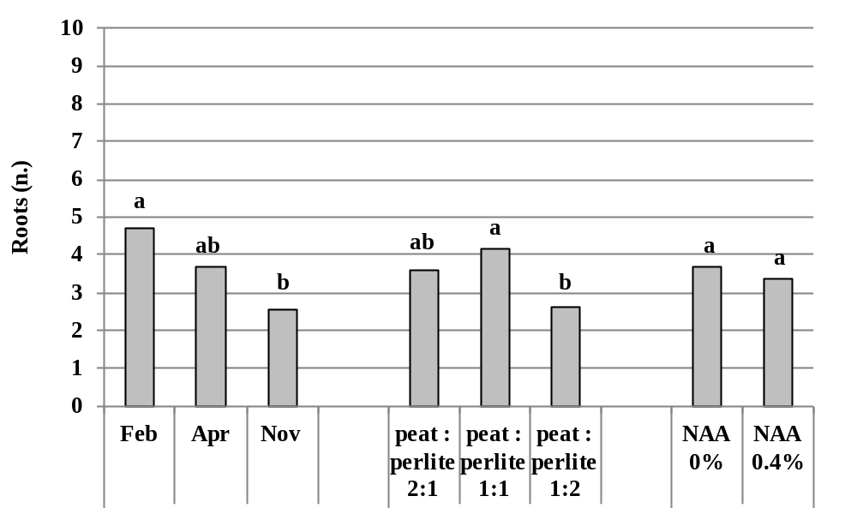

Fig. 1 – Average number of roots of A. arborescens cuttings according to harvest date, growing substrate and NAA concentration.
(Bars with different letters are significant at p≤0.05, LSD test)

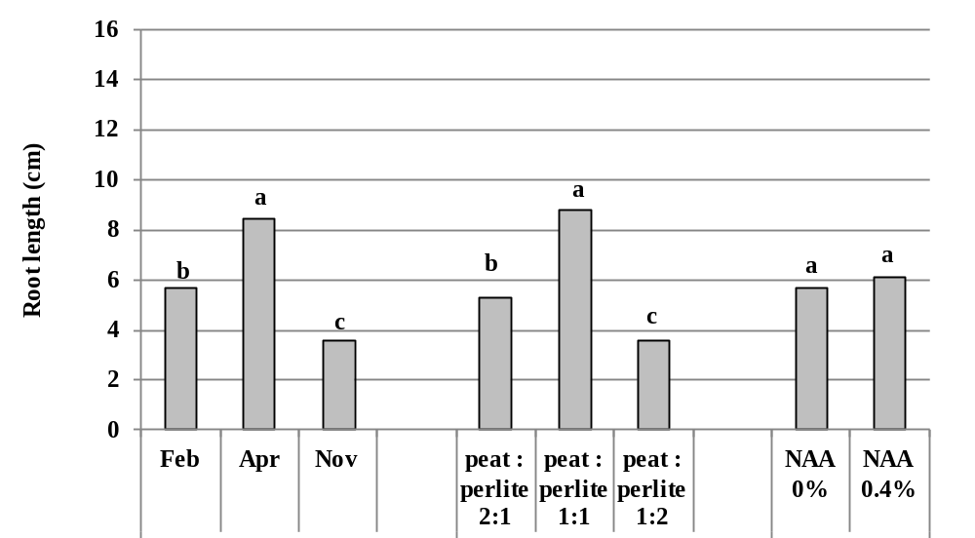

Fig. 2 – Average length of roots of A. arborescens cuttings according to harvest date, growing substrate and NAA concentrations.
(Bars with different letters are significant at p≤0.05, LSD test)

